ACCESSIBILITY GUIDE

Sky presents the Isle of Wight Festival 2026

ACCESSIBILITY GUIDE CONTENTS
WELCOME TO SKY PRESENTS THE ISLE OF WIGHT FESTIVAL 2026 4
TICKETS AND VEHICLE PASSES 5
FORMS OF ID REQUIRED 6
PRESCRIBED MEDICATION 6
BRINGING FOOD, DRINK AND BAGS TO THE FESTIVAL 7
ESSENTIAL COMPANIONS 8
GROUND CONDITIONS AND WEATHER 9
FESTIVAL SITE OPENING AND CLOSING TIMES 9
HOW TO GET TO THE ISLE OF WIGHT FESTIVAL 9
ARRIVING BY CAR AND PARKING 10
ARRIVING BY CAMPERVAN 10
ARRIVING BY FESTIVAL BUS OR BIG GREEN COACH 10
ARRIVING BY TAXI OR BEING DROPPED OFF 11
ARRIVING AT THE PEDESTRIAN ENTRANCE (GATE A5) 11
COLLECTING YOUR WRISTBANDS AT THE BOX OFFICE 11
ROUTINE SEARCHES 13
INTERNAL SITE TRANSPORT 13
INTERNAL AND EXTERNAL VEHICLE CURFEWS 13
ACCESSIBLE CAMPSITES 14
ACCESSIBLE FACILITIES AROUND THE FESTIVAL 16
ASSISTANCE DOGS 18
BRITISH SIGN LANGUAGE: PERFORMANCE INTERPRETING SERVICE 18
MEDICAL ASSISTANCE AND WELFARE 18
ISLE OF WIGHT FESTIVAL APP 19
THE ACCESSIBILITY TEAM 19
HOW TO GET HELP 19
ACCESSIBILITY MAP 20
INTERNAL TRANSPORT MAP 21

WELCOME TO SKY PRESENTS THE ISLE OF WIGHT FESTIVAL 2026
We are looking forward to welcoming you to this year’s Isle of Wight
Festival.

Please take the time to read this accessibility guide carefully. It contains essential information including what to bring to the festival, how to access the festival site, and details of the facilities available inside.
All accessible facilities and locations are marked on the accessibility map which you can find in this guide, on the Isle of Wight Festival website and on the Isle of Wight Festival App.

Please remember to share this accessibility guide with your essential companion, as it is important that they also read the information in this document.
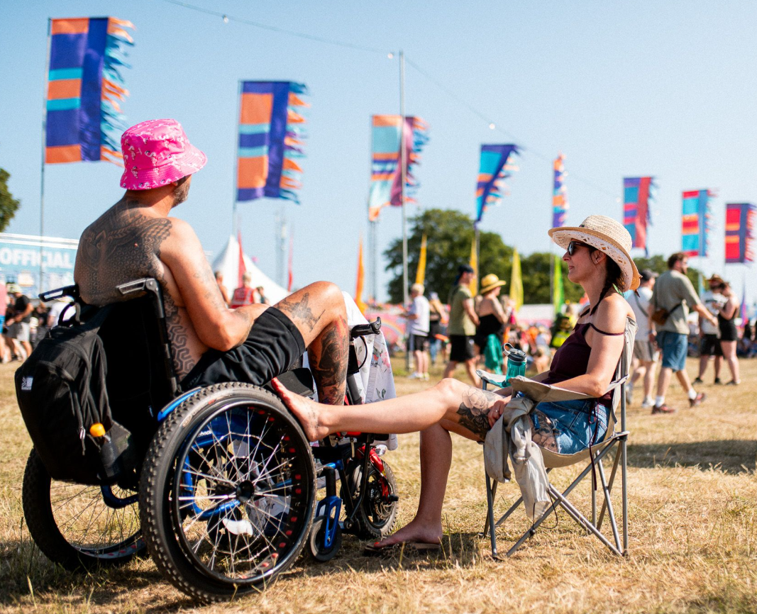
If you have any questions that aren’t answered in the guide, please do not hesitate to email the accessibility team at: accessibility@isleofwightfestival.com

TICKETS AND VEHICLE PASSES

DOWNLOAD YOUR TICKETS
If you bought your ticket from Ticketmaster, please download the Ticketmaster app on your phone and preload your ticket before arriving at the festival. This will ensure that you won’t have to worry about having a good signal on your phone at the festival.

Please open your phone’s app store and search Ticketmaster UK and
then download the app.

If you bought your ticket from The Price Is Wight, please log into your account to either download or print out your ticket.

We will need to scan the QR code on your ticket at the box office when you arrive in order for you to enter the festival. Please remember to make sure your phone is charged.

Please note that we do not provide tickets for essential companions. If you are approved to bring an essential companion, they will collect their wristbands with you at the box office. Please see the Essential Companion section for more information.

APPROVED ACCESSIBLE FACILITIES
Please find the email you received from us with confirmation of your approved accessible facilities.
To help you find this email, it was sent from accessibility@isleofwightfestival.com and the subject line is Isle of Wight Festival Accessible Application.

If you cannot find the email, please contact us
accessibility@isleofwightfestival.com before leaving home.

CAR PARK AND CAMPERVAN PASSES
Where approved, you will receive your accessible car park or campervan pass, in advance, by email. You will also receive arrival instructions telling you where to go.

Please print the vehicle pass and make sure that the pass is clearly displayed in the windscreen of your vehicle when you arrive at the festival.

FORMS OF ID REQUIRED
Please ensure you bring one of the following forms of identification with you:

- Nimbus Access Card
- Current passport
- Current driving licence
- Isle of Wight Festival Digital Access Pass and Photo ID

You will be asked to present your form of identification when collecting your wristbands.

PRESCRIBED MEDICATION
If you're bringing prescribed medication with you, please ensure that your medication is in the correct packaging with the dispensary sticker intact and issued in your name.

If you need to bring in loose medication or medication that’s not in its
original packaging, you will need to bring the prescription(s) with you.

MEDICAL MARIJUANA
Medical marijuana prescribed for daily use may be brought into the event. Please bring the medication in its prescribed form together with the original prescription supporting its use for the entire duration of your time at the event. You may be asked to show this, along with photo ID matching the name on the prescription.

STORAGE FOR REFRIGERATED MEDICATION
Refrigerated storage for medication is available at the following locations:
- The Main Arena Accessible Campsite – in the campsite manager’s
office
- The Yellow Accessible Campsite – in the campsite manager's office
- The hospital in Electric Ladyland
This facility is only for the storage of medication that requires refrigeration.

STORAGE FOR NON-REFRIGERATED MEDICATION
If you need to store non-refrigerated medication, it can be stored in the following locations:

- The Main Arena Accessible Campsite – in the campsite manager’s
office
- The Yellow Accessible Campsite – in the campsite manager’s
office

CONTROLLED SUBSTANCES
If you wish to store any controlled substances, please contact us at accessibility@isleofwightfestival.com.

LABELLING
All medication must be clearly labelled with the following:
- Your full name
- Your date of birth
- Your phone number
- Your essential companion’s full name if you wish for them to
collect and store your medication.

Medication will be signed in and out by a manager and will only be issued to the named customer or their essential companion, where applicable.

BRINGING FOOD, DRINK AND BAGS TO THE FESTIVAL

CAMPSITES
All customers can bring food, drink, including alcohol, and bags into the campsites.

ENTERTAINMENT FIELDS
Food
Accessibility customers are permitted to bring food for personal consumption into the entertainment fields (Main Arena, Strawberry Fields, Penny Lane and Electric Ladyland). This allowance applies to accessibility customers only and not to essential companions or friends and family.

Drink
Accessibility customers are permitted to bring one sealed, unopened bottle up to 1.5L of water or soft drink (no alcohol) into the entertainment fields (Main Arena, Strawberry Fields, Penny Lane and Electric Ladyland). This allowance applies to accessibility customers only and not to essential companions or friends and family.

You will be able to refill your water bottles at water points situated around the site.

Bags
For security reasons, we are only permitting customers to bring a small bag (max 40cm) into the entertainment fields (Main Arena, Strawberry Fields, Penny Lane and Electric Ladyland).

For accessibility customers who require it, a bigger bag will be permitted. Please understand that this change to the policy is for the benefit of you, the accessibility customer, only, and we cannot extend it to other members of your party.

The bag can be carried by you or someone on your behalf, if preferred.

Please remember that your bag will be searched on entry.

ON SITE SUPERMARKET – CO-OP
The Co-op supermarket will be located on-site in the main campsite, next to the Yellow Accessible Campsite.
The Co-op opening hours are:
Thursday - Sunday 07:00 to 02:00

ESSENTIAL COMPANIONS
If you have been approved to attend the Isle of Wight Festival with an essential companion, please ensure they arrive with you. Your essential companion must be present with you at check-in to receive their wristband.

We do not provide tickets for essential companions. If you are approved to bring an essential companion, they will collect their wristbands with you at the box office. You will need to show your ID to collect your wristbands, but your essential companion just needs to be at the check in with you.

Please ensure that your essential companion is willing and able to fulfil all your requirements, as needed, and will be able to assist during an evacuation or other emergency.
If the Isle of Wight Festival finds evidence that your essential companion is not attending for the purpose of supporting your needs, they may be asked to leave the festival. Before taking this action, we will inform you, share the evidence used to reach our decision, and discuss alternative means for your needs to be supported.

GROUND CONDITIONS AND WEATHER
The Isle of Wight Festival is an outdoor event, and most of the terrain is grass. Solid pathways or hard ground are absent in some parts of the event site. Some of the stages and entertainment areas are in areas with inclines or slopes.

There are designated accessible routes around the festival site. They are a mix of trackway and hardcore tracks.
In the event of rain, it is important to know that the terrain will likely become muddy and wet, making it harder to navigate. We recommend using wheelchairs or mobility scooters suitable for this terrain and bringing the appropriate emergency tyre repair kit.

Whilst we hope for sunshine, please pack gear for all kinds of weather.

FESTIVAL SITE OPENING AND CLOSING TIMES
There are various areas within the festival site that have different opening times. Please go to our website or the festival app for full details.

HOW TO GET TO THE ISLE OF WIGHT FESTIVAL

FESTIVAL SITE ADDRESS
The Isle of Wight Festival is located at Seaclose Park, Fairlee Road, Newport, Isle of Wight PO30 2JX.
For travel information to the island, please click here to see our website. If you are arriving without a vehicle, there are shuttle buses from the ferry ports to the festival.

ARRIVING BY CAR AND PARKING

There is accessible car parking at Gate A1 and Gate A6. This is marked on the accessibility map. If you have been approved for accessible parking at the festival, details of which car park you have been allocated are included in the confirmation email received from the accessibility team.

When you receive your vehicle pass, you will also receive arrival instructions giving more information on how to get to your allocated car park.

Please note that if you are coming to the festival on Thursday and are parking at Gate A6, you then will need to make your way to Gate A5 to enter the festival.

ARRIVING BY CAMPERVAN
If you have been approved for and have purchased an accessible campervan pass, you will receive arrival instructions with your pass.

If you are in the accessible campervan field, you will enter at Gate A6. If you are in the standard campervan field, you will enter at Gate A2.

Please note, if you are staying in the standard campervan field, you will be provided with your accessibility wristbands on arrival and do not need to go to a box office to collect them.

You can refer to the gate opening times on our website or in the festival app.

ARRIVING BY FESTIVAL BUS OR BIG GREEN COACH
If you are arriving by festival bus, you can be dropped at either the festival bus station at Gate A3 or at Gate A6.

If you are camping in the Main Arena Accessible Campsite or want to go straight into Main Arena, you should get off at Gate A6.

For all other campsites, including the Yellow Accessible Campsite, or to access the festival site before the Main Arena opens, you should get off at A3.

You can refer to the gate opening times on our website or in the festival app.

ARRIVING BY TAXI OR BEING DROPPED OFF
The taxi and private pick-up/drop-off points are at Gate A2 or Gate A6 depending on where you want to go on arrival.

If you are camping in the Main Arena Accessible Campsite or want to go straight into Main Arena, you should be dropped off at Gate A6.

For all other campsites, including the Yellow Accessible Campsite, or to access the festival site before the Main Arena opens, you should be dropped off at A2.

You can refer to the gate opening times on our website or in the festival app.

ARRIVING AT THE PEDESTRIAN ENTRANCE (GATE A5)
There is a dedicated pedestrian entrance for non-campers at Gate A5. This gate opens to all customers on Friday.

As an accessibility customer, if you’re coming to the festival as a pedestrian on Thursday and want to use this gate, you can do so from 18:00.

You can refer to the gate opening times on our website or in the festival app.

COLLECTING YOUR WRISTBANDS AT THE BOX OFFICE
The locations of all box offices are marked on the Accessibility Map.

Which box office you go to will depend on where you are arriving.

Arriving at | Box Office
Gate A1 | Gate A1 Box Office
Gate A2 | Gate A1 Box Office
Gate A3 | Gate A3 Box Office
Gate A5 | Gate A5 Box Office
Gate A6 (staying in the Main Arena Accessible Campsite or Accessible Campervan area) | Main Arena Accessible Campsite Box Office
Gate A6 (non-campers) | Gate A6 Box Office

BOX OFFICE OPENING TIMES

Gate A1 Box Office
Thursday 07:00 – 22:00
Friday 08:00 – 21:00
Saturday and Sunday 09:00 – 20:00

Gate A3 Box Office
Thursday 09:00 – 22:00
Friday 09:00 – 22:00
Saturday and Sunday 09:00 – 22:00

Gate A5 Box Office
Thursday 17:00 – 21:00 (accessibility customers only)
Friday 12:00 – 22:00
Saturday and Sunday 10:30 – 22:00

Gate A6 Box Office
Thursday 12:00 – 21:00
Friday 12:00 – 21:00 (gates open at 14:00)
Saturday 10:00 – 21:30 (gates open at 11:00)
Sunday 10:00 – 21:00 (gates open at 11:00)

Main Arena Campsite Box Office
Thursday 09:00 – 22:00
Friday 09:00 – 21:00
Saturday 10:00 – 20:30
Sunday 10:00 – 20:00

BOX OFFICE INFORMATION
When you get to the box office, please have your ticket, QR code and photo I.D ready.
If you have been approved to bring an essential companion, they must attend the box office with you to collect their wristbands.
Seating, accessible toilets and water will be available close to the box offices. All box offices have dedicated accessibility windows and lowered counters.

ROUTINE SEARCHES
Festival attendees are subject to a search of their bags, mobility aids and person. You may request a female or male member of security to complete the search. Dogs may also be present. There will be accessible toilets near the search lanes.
To avoid any delays or issues, please review the prohibited items list that you cannot bring to the festival by visiting our website.

INTERNAL SITE TRANSPORT
A minibus and buggy service will be available between dedicated bus stops around the site. The accessibility transport map shows the locations of the bus and buggy stops.

If you are collecting your wristbands from the Gate A1 Box Office, you can either go through the entry lanes or use the internal transport to get to the Yellow Accessible Campsite.

This service is for the use of accessibility customers and their essential companions only. Please only use this service if you need it and, where possible, give priority to those who cannot travel over distances. Please be aware that there will be queues to use this service during busy times.

INTERNAL AND EXTERNAL VEHICLE CURFEWS
Please be aware that at the end of each day, we must enforce strict vehicle curfews to protect the safety of everyone leaving the festival.

The vehicle curfews will come into place at the following times:

- Thursday 10:20 to 11:40
- Friday 23:20 to 00:40
- Saturday 23:20 to 00:40
- Sunday 22:20 to 23:40
Please be aware that these times are subject to change at short notice.

INTERNAL VEHICLE CURFEWS
During the vehicle curfew, the minibus and buggy service will stop running, including the routes between the Main Arena and the Yellow Accessible Campsite.

If you wish to use the internal transport or avoid heavy crowd movement, you will need to leave prior to the curfew times. This will mean leaving the Main Arena before the headliner has finished.

Once the curfew begins, you can either make your own way on foot or wait at your location until the curfew is lifted. Please be aware, there are likely to be queues to use the minibuses and buggies after the curfew lifts.

EXTERNAL VEHICLE CURFEWS
If your car is parked at Gate A6, you will not be able to leave during the vehicle curfew. If you want to avoid waiting until the end of the curfew, you will need to leave before the curfew begins. This will mean leaving before the headliner has finished.

ACCESSIBLE CAMPSITES
There are two accessible campsites at the Isle of Wight Festival: the Main Arena Accessible Campsite and the Yellow Accessible Campsite. If you do not know which Accessible Campsite you are staying in, please contact the accessibility team at accessibility@isleofwightfestival.com

SETTING UP
When you arrive, you will be directed to an available camping pitch. Our team will be there to assist you. Wheelchair users and those with restricted mobility will take priority in being positioned close to the accessible walkway and facilities.

Due to space limitations, please be mindful of the size of any tents or gazebos you are bringing. You may be asked to move them if they are taking up too much space. Please consider fellow campers when setting up your pitch.

You are not permitted to camp in the fire lanes, hard standing or areas without grass. Any tents found in these areas will be moved.

CAMPSITE FACILITIES
The facilities listed below are available in both accessible campsites.
You are welcome to use the facilities even if you are not camping in the accessible campsites.

Medication Storage
You can store medication in the campsite manager’s office.

There is a fridge for medication which requires refrigeration.

All medication must be clearly labelled with the following:
- your full name
- your date of birth
- your phone number
- Your essential companion’s full name if you wish for them to collect and store your medication.

Medication will be signed in and out by a manager and will only be issued to the named customer or their essential companion, where applicable.

Charging Tents
Charging tents are located inside both accessible campsites, equipped with charging points for electric wheelchairs and medical devices such as nebulisers.

Please note, while there is security within the campsite, the charging tent does not have dedicated supervision at all times.

Lockers
Lockers are available to book online. Please go to the website to book in advance to avoid disappointment!
There are two sizes available, both with sockets for device charging.
Lower level lockers are available to book.

Small locker with socket (9.5cm x 19cm x 32.5cm) Large locker with socket (24cm x 20cm x 32cm)

Accessible Toilets And Showers
Standard and wheelchair accessible toilets and showers are located inside each accessible campsite.

Changing Places Unit
Changing places units are available in the accessible campsites and include a changing bed, toilet, sink and a hoist. Please bring your own sling if required.

Washing Facilities
There are accessible sinks in both campsites.

Water Point
There will be drinking water points for you to fill up water bottles.

Critical Power
Please note that customers who require and have been approved for critical power will be positioned in a designated area of the campsite. The power connections will be supplied to the approved customer’s tent at specific pitches in this area.
Please let the team know that you have been approved for this facility when you arrive.

GENERAL CAMPSITES
All General Campsites have accessible toilets. Accessible showers can be found in the main shower block in the Green Campsite.

ACCESSIBLE FACILITIES AROUND THE FESTIVAL

ACCESSIBLE TOILETS AND CHANGING PLACE UNITS
Accessible toilets are located at every toilet block and at the accessible viewing areas. Please remember to show your accessibility wristband when a staff member asks to see it.

There are changing places units in the Main Arena Accessible Campsite and the Yellow Accessible Campsite. Please bring your own slings.

All accessibility customers will be able to enter the campsites to use the facilities.

We respectfully ask that all customers be considerate of one another and be mindful of other customers who have urgent toilet requirements. Please be aware that toilet facilities will be busier during peak times such as artist changeovers.

BAR SERVICE AREAS
Accessible bar lanes with lowered service areas are available at the main festival bars. Please look out for the wheelchair symbol. You and your essential companion can access the lowered bar areas by using the dedicated lane.

ACCESSIBLE VIEWING AREAS
There are accessible viewing areas at the following stages:

- Main Stage
- Big Top
- Electrolove

Raised Viewing Platform
- The raised viewing platforms are equipped with ramped access, wheelchair-accessible toilets, and charging points.
- If you have been approved for the raised viewing platform, you will receive a wristband that lets you on.
- You can bring your essential companion on to the raised viewing platform with you.
- If you have not been approved for an essential companion, you can bring someone else with you.
- Viewing platforms are not covered. Please dress appropriately for all weather conditions.
- If your companion needs to leave the platform temporarily (for example, to use the toilets) they will be given a temporary pass card by security to hand back when they return.
- Once the platform is at capacity a one in, one out policy will be implemented.
- Smoking, including e-cigarettes & vapes, is not permitted.
- Staff and security have the right to ask you to leave the platform if you are behaving inappropriately.

Ground Viewing Area
- Ground viewing areas are available to those who need a less crowded area and the option of sitting for short periods of time.
- The ground viewing areas are situated in front of the raised viewing platforms and are separated from the main crowds by a barrier.
- The ground viewing areas are primarily standing areas, although limited seating is available.
- If you are in the ground viewing area, you can use the accessible toilets located behind the raised viewing platform.
- If you have been approved for the ground viewing areas, you will have received a wristband that gives you access.
- Once the area is at capacity, a one in one out policy will be implemented.
- Only you and your essential companion (or friend) will have access to the ground viewing areas. This allows us to accommodate as many customers, who require the use of this facility, as possible.
- Staff and security have the right to ask you to leave the ground viewing areas if you are behaving inappropriately.

ASSISTANCE DOGS
There are spending areas in both accessible campsites and near the viewing areas in the main arena. Please make sure you clear up after your dog, using the bins provided.

Please ensure the dog is kept on a lead with an appropriate harness and jacket. If our staff feel that the dog is not fulfilling its role or causing disruption to other customers, we will ask for the dog to be removed from the site.

BRITISH SIGN LANGUAGE: PERFORMANCE INTERPRETING SERVICE
A British Sign Language performance interpreting service will be provided if requested in advance, by fully qualified interpreters.

If you have indicated that you require this service and have given consent for your contact details to be shared with the interpreters, they will contact you directly. This is so that you can liaise with them about what performances you want interpreted.
If you would like to be contacted by the interpreters and have not yet given your consent, please contact us at accessibility@isleofwightfestival.com.

MEDICAL ASSISTANCE AND WELFARE

MEDICS
The festival hospital is located in Electric Ladyland. If you require urgent medical attention, please alert a member of staff who can assist you.
Medics are located close to the main arena viewing areas, please ask a steward or the platform manager if you need medical assistance.

WELFARE
Welfare tents are located in the Main Arena and Electric Ladyland in the main campsite. Experienced and caring staff are on hand to provide confidential advice about drugs, alcohol, sexual health and general assistance, counselling, and advice for anything that is troubling you.

SENSORY CALM TENT
There is a Sensory Calm Tent in the main arena managed by EventWell. The space offers co-regulation, emotional support and onsite mental health first aid. Inside you’ll find noise-cancelling headphones, fidgets, weighted blankets, sensory dens, and quiet activities like chess, dominoes, colouring and puzzles.

EVENT WELL BUDDIES
Event Well Buddies are on hand if you need help to navigate the festival. You’ll find them at the Sensory Calm tent, the accessible campsites and walking around the festival site. They are there to offer support, information and a friendly face. All the Buddies are trained in accessibility and neuro-inclusion and are there to help you to find your way around the festival and manage overwhelm.

ISLE OF WIGHT FESTIVAL APP
Please download the festival app to your mobile phone by visiting the Apple Store or Google Play and searching for Isle of Wight Festival.

The app contains helpful information, including set times, maps, and important updates by push notification.

THE ACCESSIBILITY TEAM
Our accessibility team will be on hand to look after you whilst onsite. Accessibility team members can be identified by their pink tabards.

Our accessible campsite managers are on duty, providing 24-hour cover. Please feel free to ask them any questions or report issues.

HOW TO GET HELP
If you need assistance, please speak to a team member at one of the following locations:

- Accessible box offices (on arrival)
- Accessible campsites
- Accessible viewing areas.
You can also contact the team by email at accessibility@isleofwightfestival.com

ACCESSIBILITY MAP
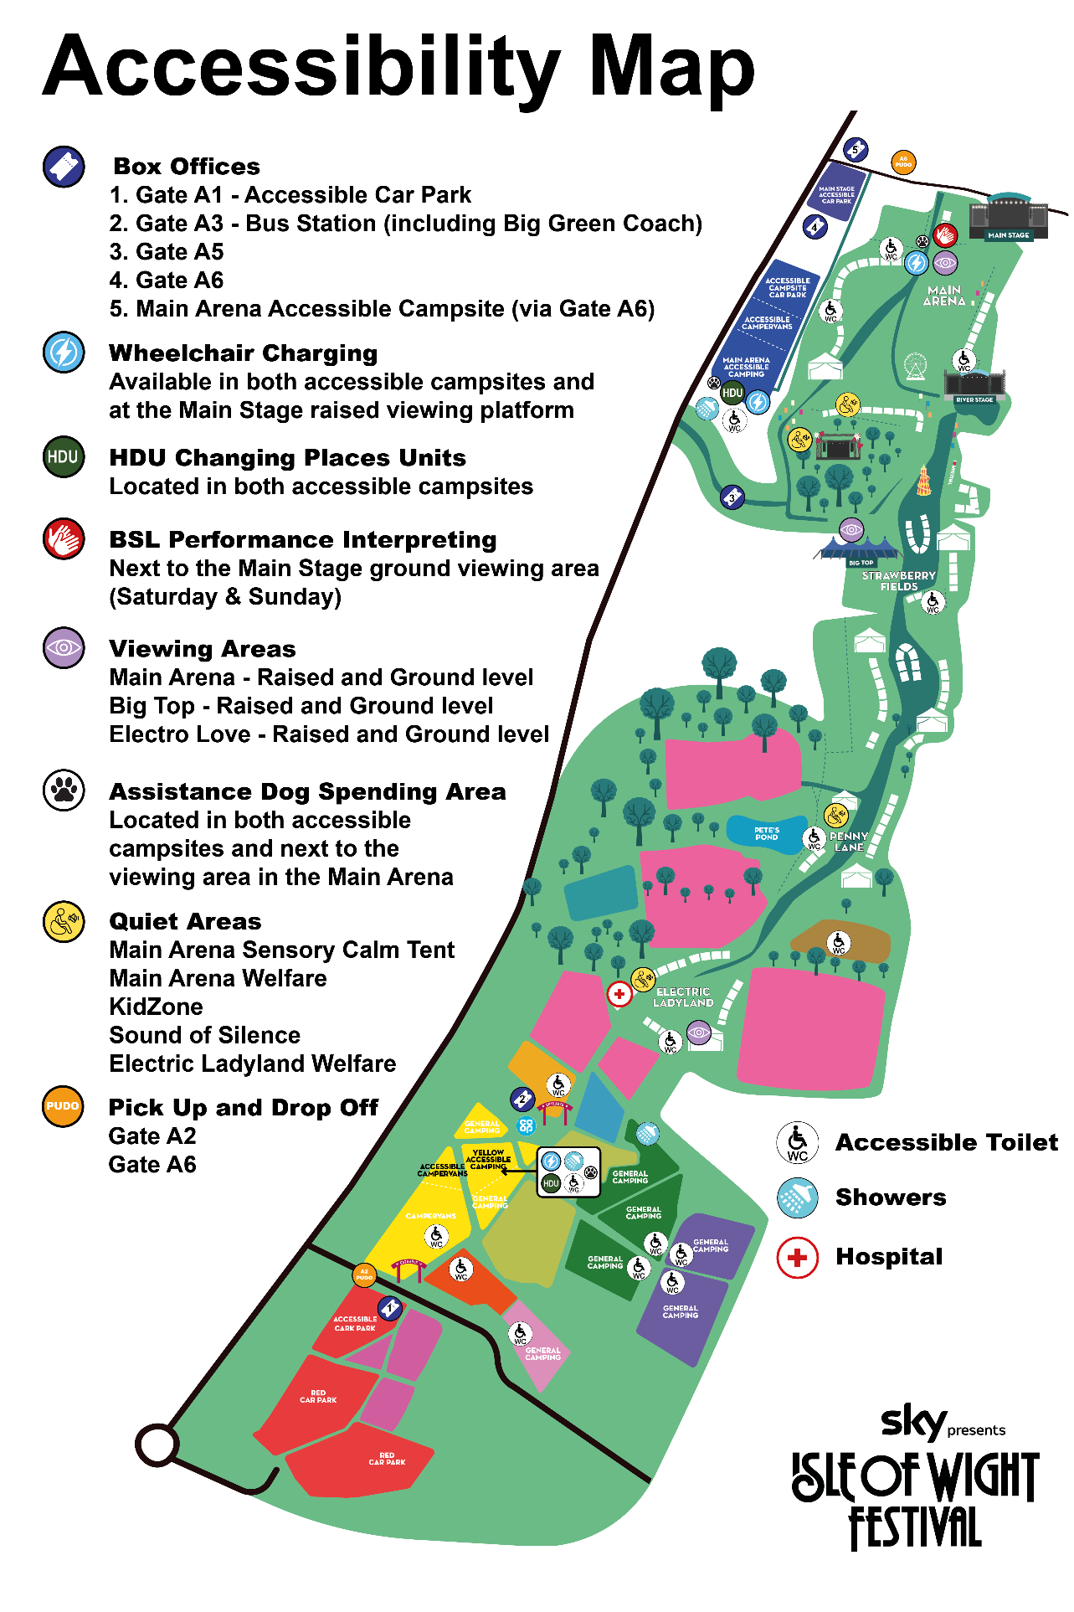

INTERNAL TRANSPORT MAP
